**Q1) 3 Levels of Processing**

Ans:

→ Used in Usability Design

→ It measures interactive user experience with the user interface.

→ Three levels Visceral, Behavioural, Reflective

→ **Visceral:** processing human reaction to visual and sensory aspects of the product before they interact with it.

→ **Behavioral:** Tells user how to respond to the message (push, pull action on glass door)

→ **Reflective:** Analysis and reflection of all experiences done in past is stored (analyzing what user wants)

**Q2) 7 steps of action**

Ans :

→ Introduced by Donald Norman

→ two aspects 1) Execution 2) Evaluation

→ Execution involves:

1. Setting up the goal of action (Want to save pdf)
2. Setup plan of action (Need to select save option in file menu)
3. Select an action or a sequence of actions that will lead you to your set of goals.
4. Execution of action (Clicking on Save button)

→ Evaluation involves:

1. Identify the state of the external world (Observe the progress bar or loading screen)
2. Interpreting the state of the external world (Progress Bar Completes)
3. Evaluating the outcomes (Check if pdf exist in the desired location)

**Q3) Human Centric Design**

Ans

→ Creative Approach for problem-solving

→ It is a framework to develop solutions to problems involving the human perspective

→ User Satisfaction is the main goal of Human Centric Design

→ Innovate > Research > Use Cases > Prototype/Evaluation > Validate > Innovate

→ The design is based on an understanding of user, tasks, and environment

→ The user is involved throughout the process

→ It is iterative

→ Advantages: Improves usability and understandability of product and overcome poor design on the product

→ Disadvantages: Software complexity still remains and also takes more time

→ Example: No Parking

**Q4) Software Evolution Process**

Ans:

→ Process of developing software product using software engineering principles and methods is referred to as software evolution.

→ process to develop, maintain and update software.

→ change request > Impact analysis > Release Planning > System Update > System Release

→ Requirement Gathering

→ prototype creation and show it to users to get feed back

→ user suggest changes, on which update and maintenance keep on changing too

→ Product is finished still advance technology and changing req force software product to change

→ Creating software from scratch is not feasible and economical

→ Laws:

1. S-type: Solution and method to achieve goals are understood before coding
2. P-type: specification can be described but solution is not obvious instantly
3. E-type: High Degree of evolution as various changes in law taxes etc

**Q5) Persona & steps**

Ans

→ Also known as User persona, Customer Persona, Buyer Persona

→ Means user experience

→ It is a way to model, summarize, communicate research about people observed.

→ Persona is not a actual person but a fictional character

→ Uses: Gain perspective, narrative practice, predicting outcomes

→ Steps:

1. Identify User Behaviour pattern
2. Arrange Interview as per behaviour
3. Recognize pattern
4. Generate various user characteristics and goals
5. Check completeness of goal
6. Explain all attributed and behavouir
7. Design various persona

**Q6) Qualitative and Quantitative Research**

Ans

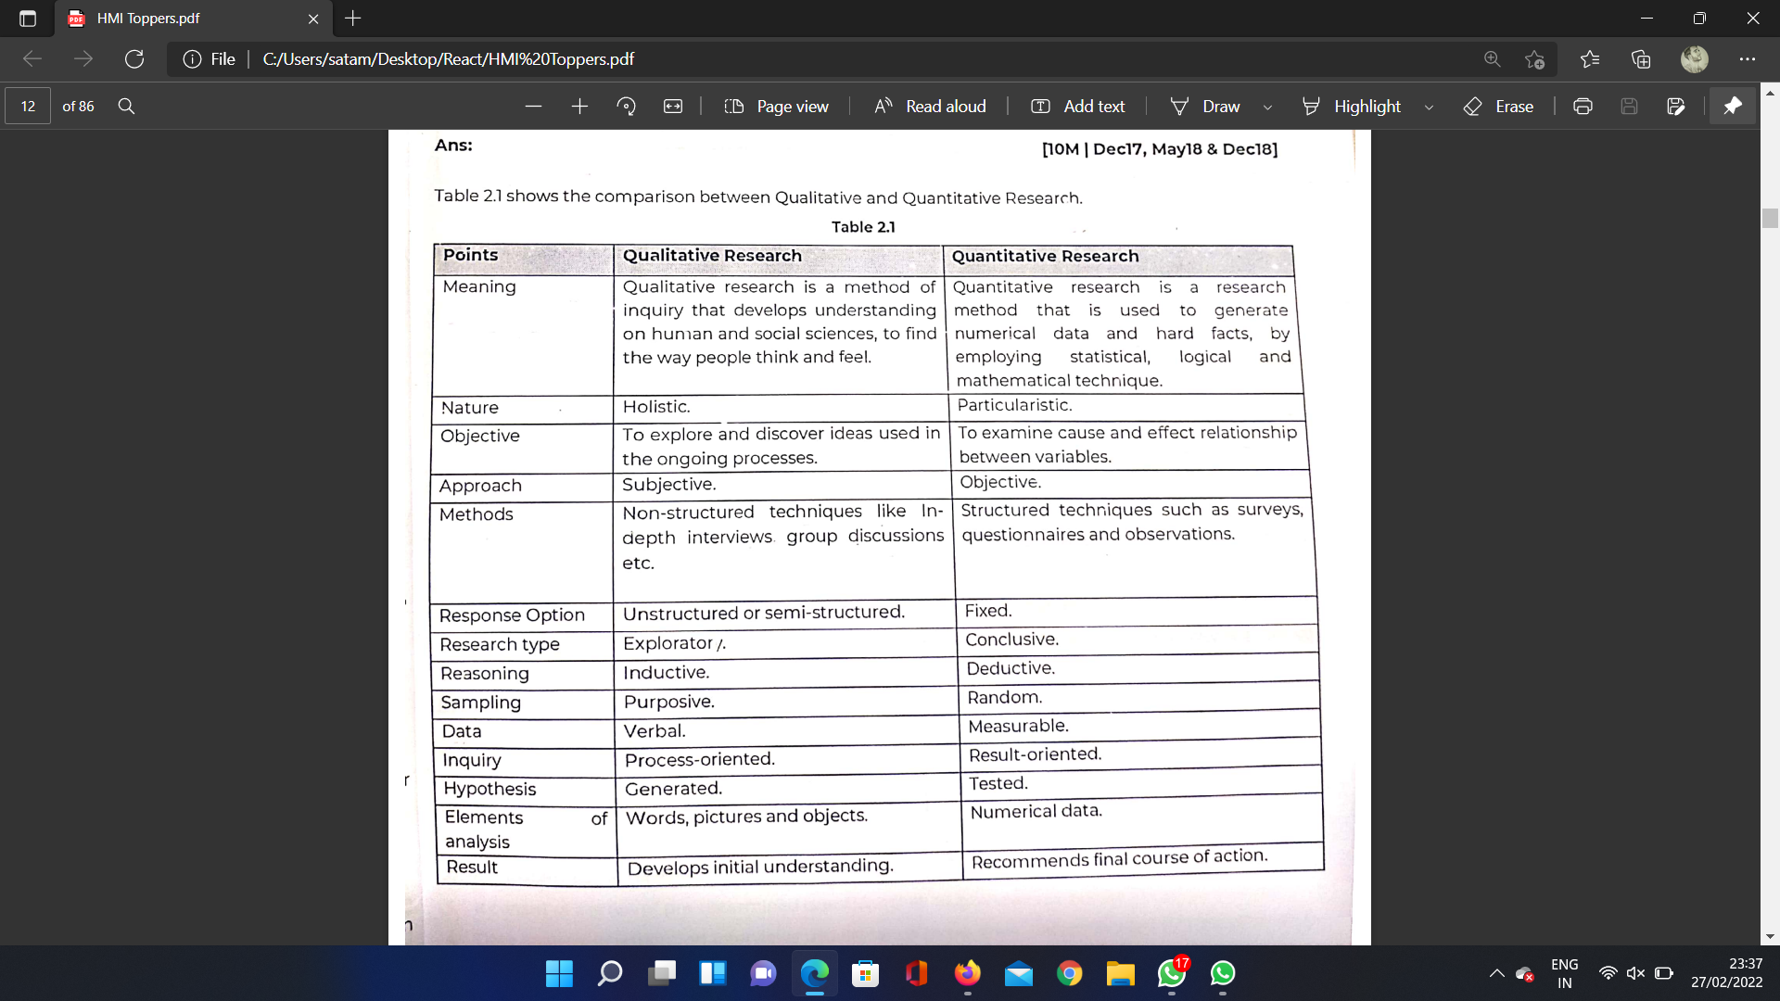

**Q7) Implementation Model vs Mental Model**

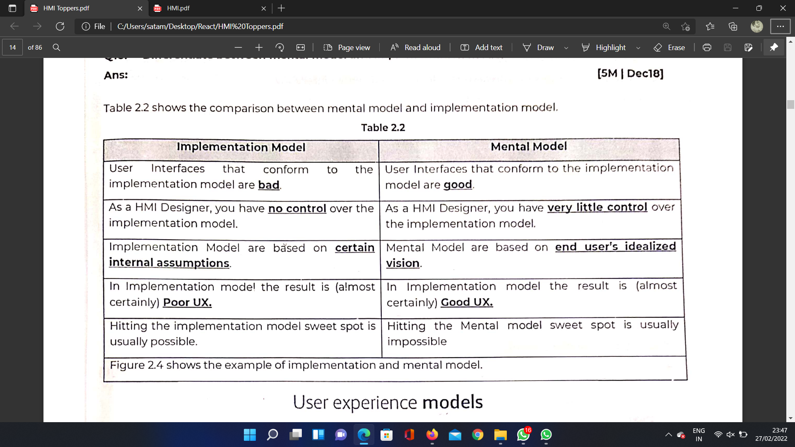

**Q8) Types of Interviews**

Ans

→ Structured:It is a quantitative Standard Interviews with pre-determined questions that all interviewees ans in same order also data analysis tends to be more straightforward.

→ Unstructured: It is a qualitative non-directive interview in which questions are not prearranged which is informal manner

→ Semi Structured:It is qualitative Component of both structured and unstructured where interviewer prepares set of same questions to be answered with additional questions to clarify

**Q9) Goal Directed Design Process**

Ans

→ It is user centered methodology

→ Developed by alan cooper

→ Broken down into foll steps

1. Research Phase (market survey, interviews and user observations)
2. Modelling Phase (Model includes information flow and work flow which helps to understand user in details)
3. Requirement Definition Phase (provide connectivity between user,model and product framework)
4. Framework Phase (provide actual product design and framework )
5. Refinement Phase (detail of system and product implementation)
6. Support Phase (Application and design level support to meet future requirements)

**Q10) Designs for Accomodating users:**

→ Main goal is to identify whether user is expert or beginner

→ helps designer to design system as per user requirements

→